TOPIC 6: BACKTRACKING

EXP 1/2 : N-Queens Problem – Visualization

AIM: To visualize the solutions of the N-Queens problem and understand correct queen placement using graphical representation.

CODE

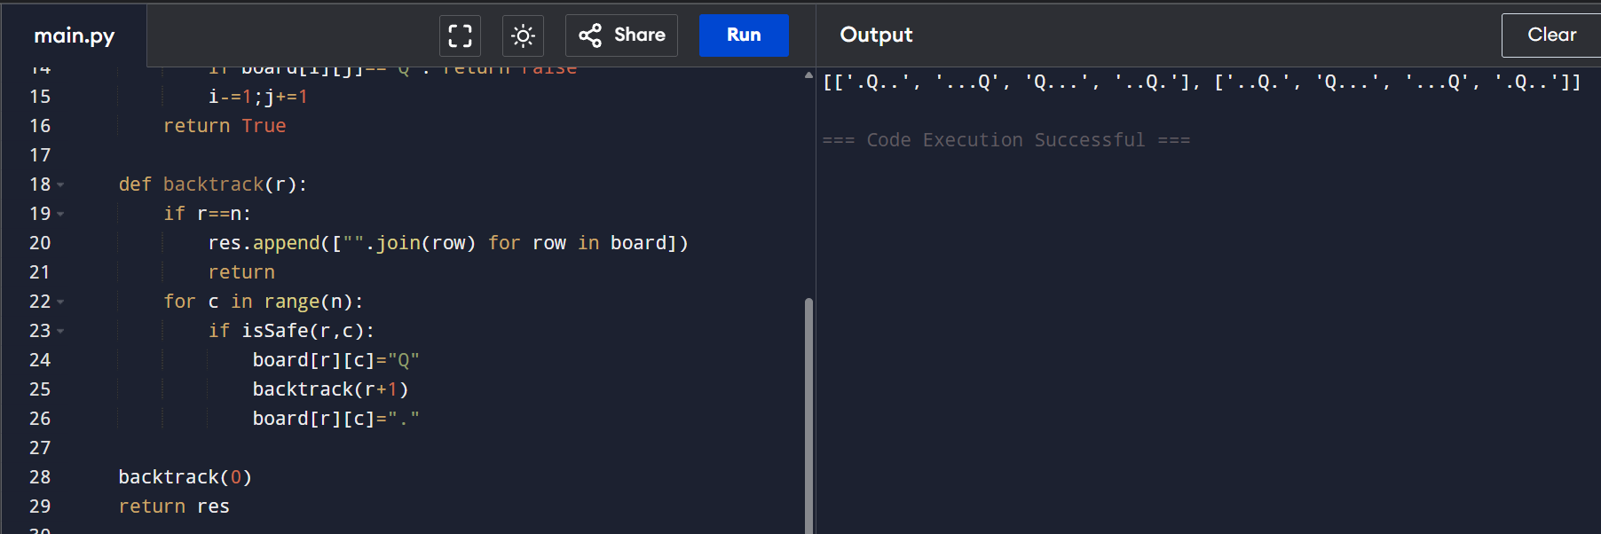
RESULT: Valid queen placements are visualized, helping to understand backtracking and conflict resolution.
EXP 3/4: Sudoku Solver (Backtracking)

AIM: To solve a Sudoku puzzle by filling empty cells using backtracking.
CODE
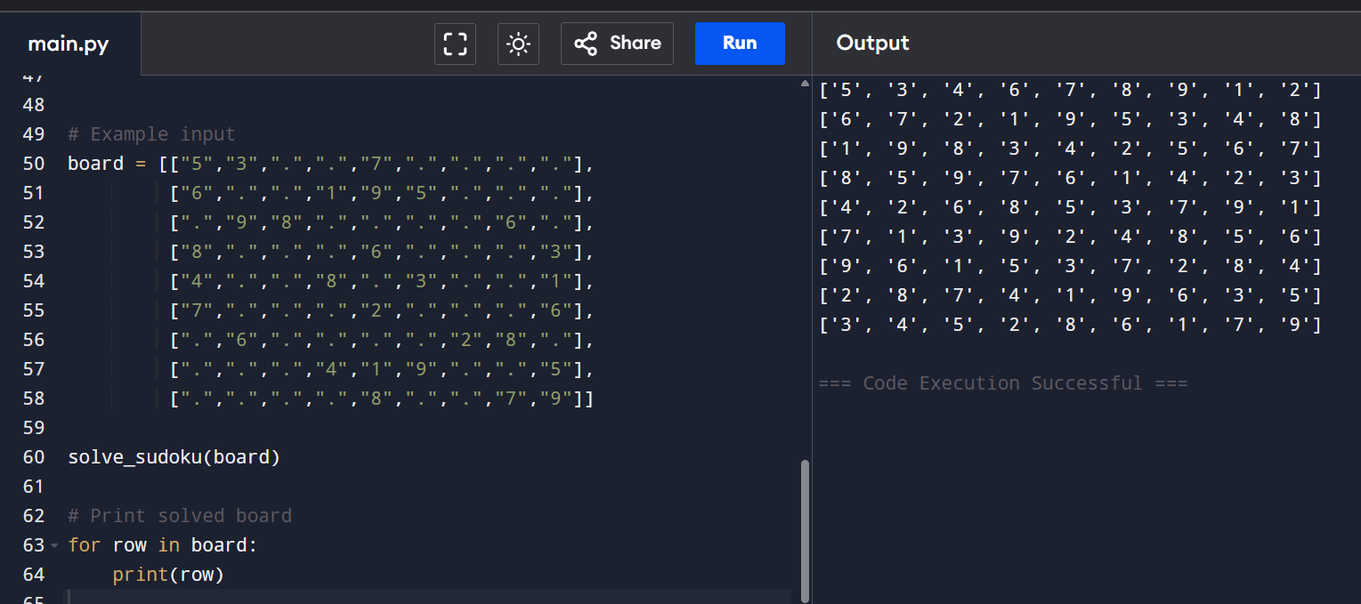
RESULT: Sudoku puzzle is solved correctly following all rules.

EXP 5: Target Sum Expressions

AIM: To count the number of expressions formed using + and − operators that evaluate to a target value.
CODE
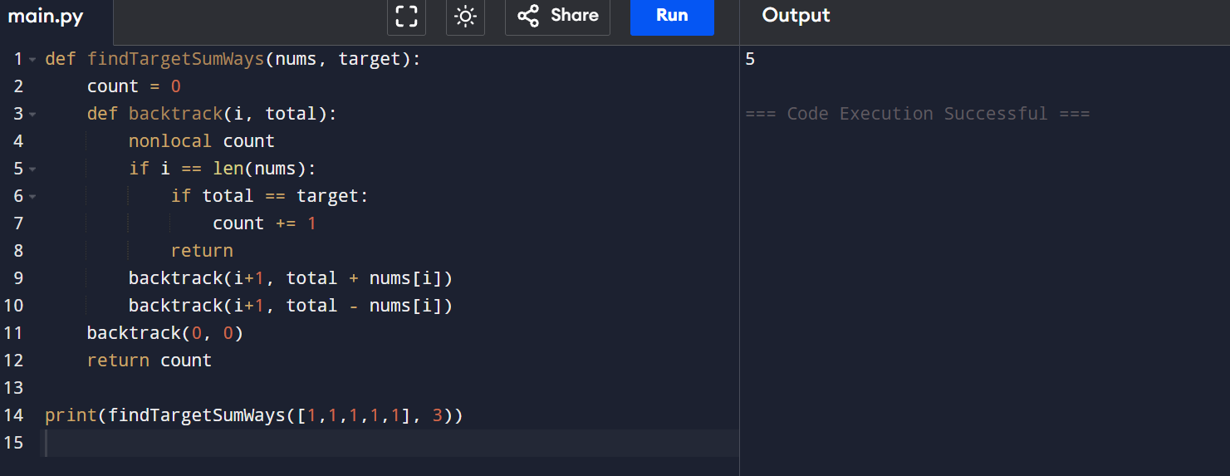
RESULT: All valid expressions achieving the target sum are counted.

EXP 6: Sum of Subarray Minimums

AIM: To calculate the sum of minimum values of all contiguous subarrays.
CODE
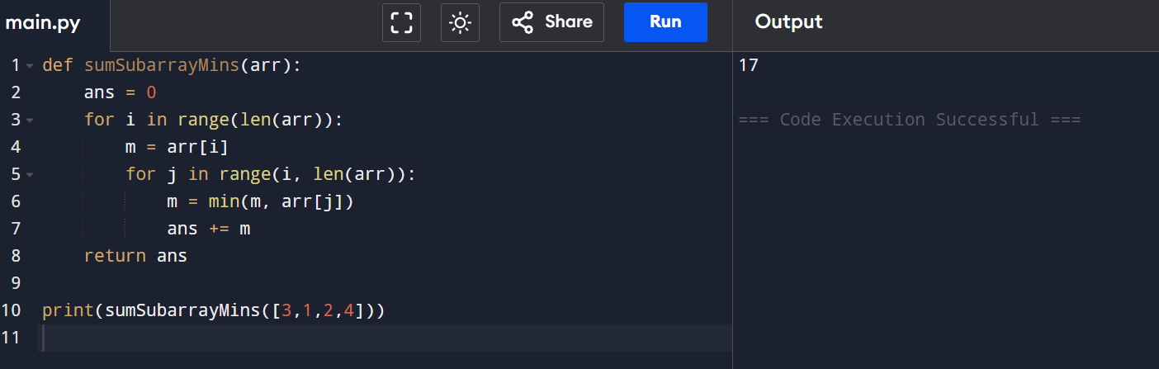
RESULT: Sum of subarray minimums is computed correctly.

EXP 7: Combination Sum

AIM: To find all unique combinations that sum to a target using unlimited candidate usage.
CODE
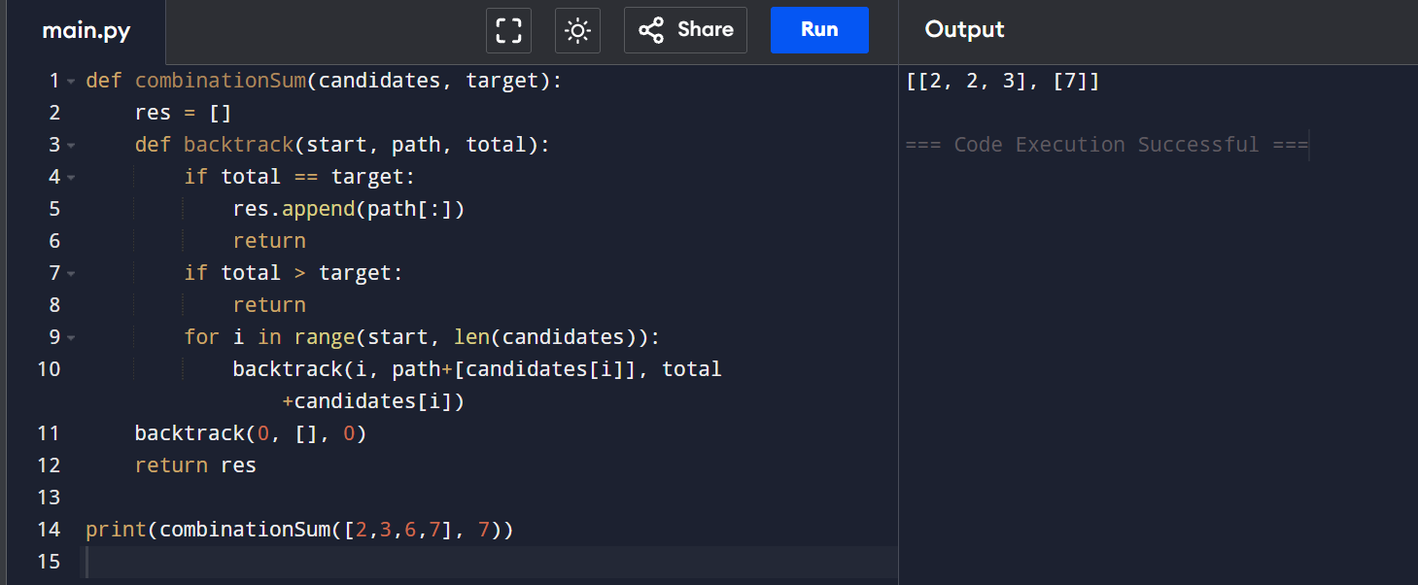
RESULT: All valid combinations are generated without duplicates.

EXP 8: Combination Sum II

AIM: To find unique combinations where each number is used once.
CODE
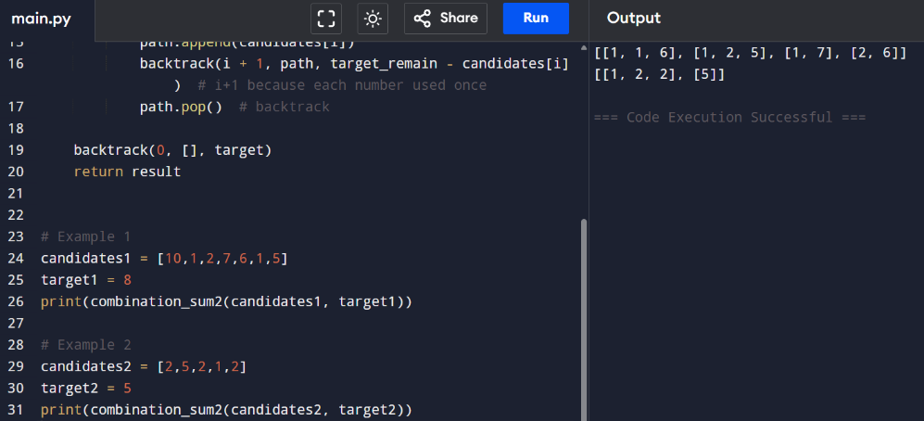
RESULT: Unique combinations summing to target are obtained.

EXP 9: Permutations

AIM: To generate all permutations of a given array.
CODE
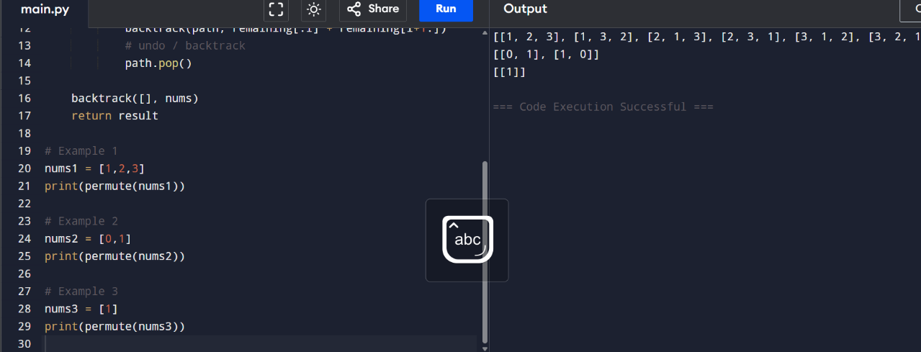
RESULT: All possible permutations are generated.

EXP 10: Unique Permutations

AIM: To generate unique permutations when duplicate elements exist.
CODE
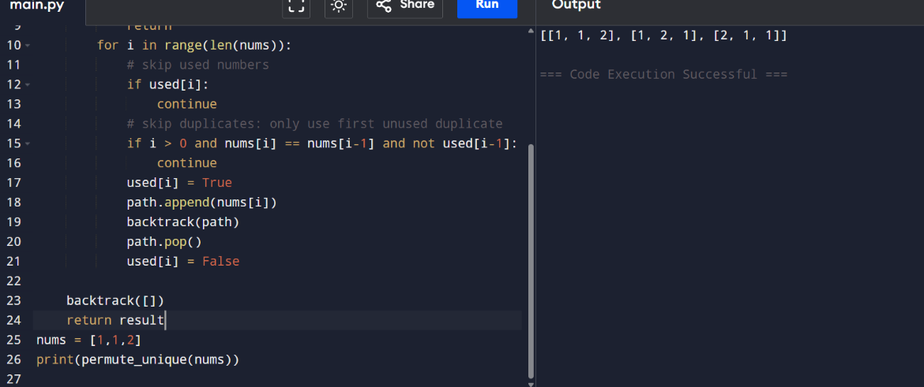
RESULT : Duplicate permutations are avoided successfully.

EXP 11: Graph Coloring

AIM: To color a graph using minimum colors without adjacent conflicts.
CODE
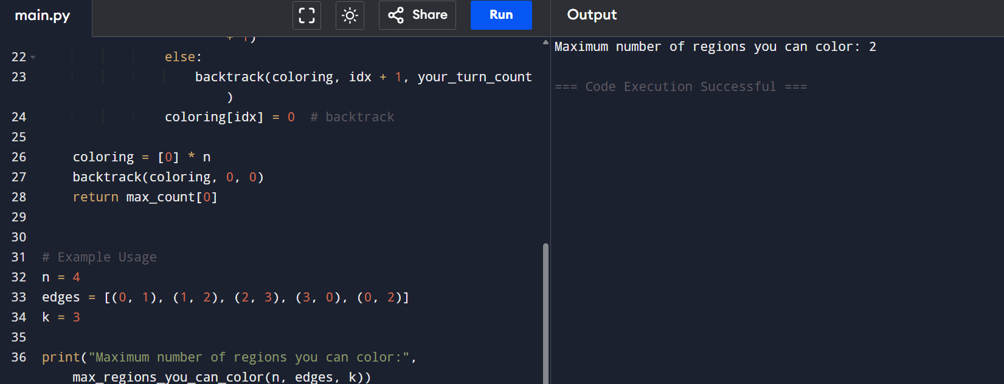
RESULT: Graph is colored with minimum conflicts.
EXP 12:/14: Subset Generation

AIM: To generate all subsets of a given set.

CODE
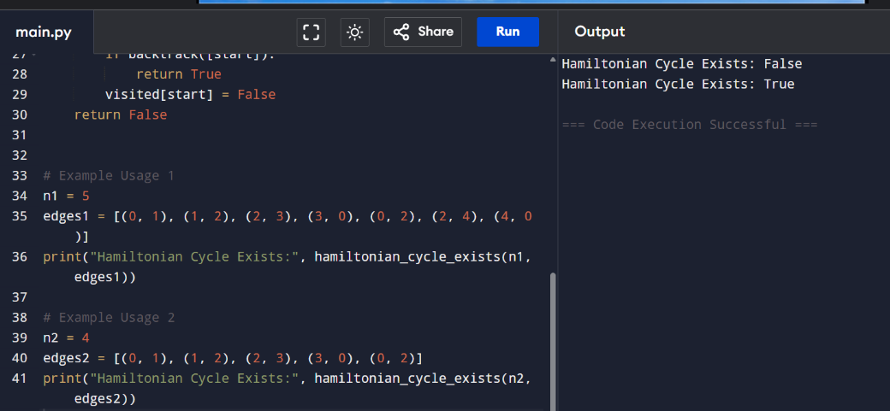
RESULT: All subsets are generated correctly.

EXP 15: Subset Generation (Lexicographic)

AIM:To generate all subsets of a set.
CODE
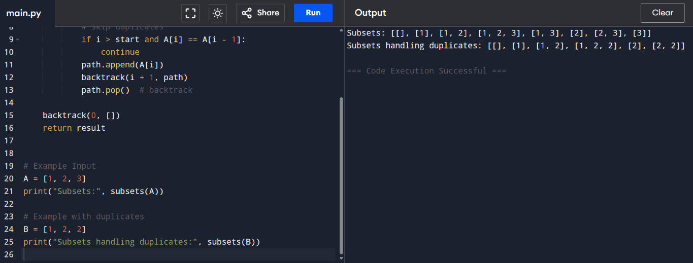
RESULT: All subsets are generated successfully.

EXP 16: Subsets Containing a Given Element

AIM: To generate subsets containing a specific element.

CODE

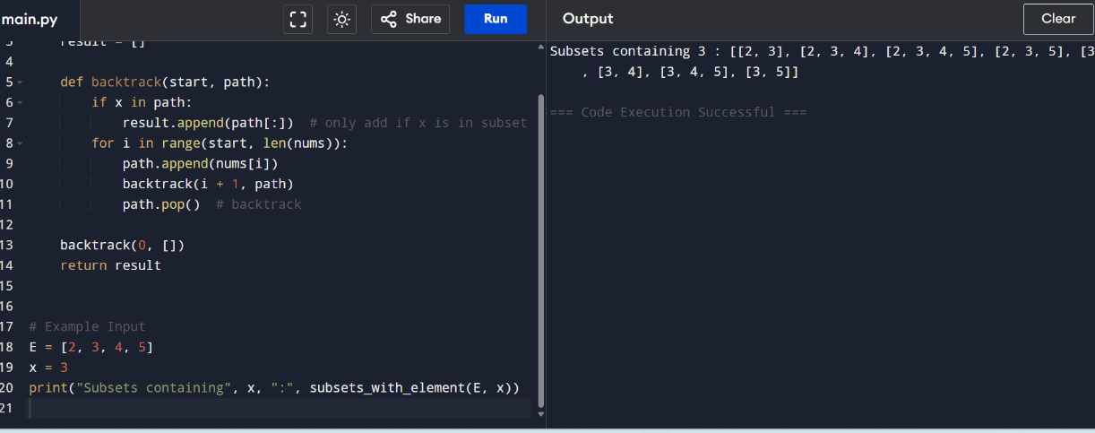

RESULT: Required subsets are obtained.

EXP 17: Word Subsets

AIM: To find universal strings from words1.

CODE

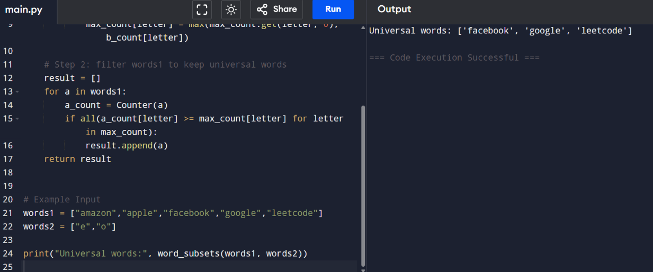

RESULT: All universal strings are correctly identified.

